|  |  |  |  |
| --- | --- | --- | --- |
| **Instructor** |  | **Due Date** |  |

**PROJECT Using MS Sway to Design a Graphics Presentation**

**Objective** To use MS Sway to design and utilize a graphics presentation.

***PROJECT DESCRIPTION***

This lab project has you constructing and utilizing a graphics presentation, per the instructions which follow.

You will use various slides ( cards ) for this graphics presentation. The theme of the presentation is outlined below.

Including your Title Slide, incorporate a minimum of ten slides in your presentation.

**Role Play Game: Locate the Secret Tunnel**

When designing your Sway application, you can use a Role Play Game as your presentation theme.

Think of a Role Play Game ( RPG ) where the players must locate a secret tunnel, which leads to a mysterious room whereby is stored a collection of lost ancient coins.

For your presentation, you can use some animated images of your game’s main characters and then describe their roles in the game.

Also, outline the steps for successful gameplay by showing the tasks that the characters must perform to locate the Secret Tunnel. Include some obstacles that the characters may encounter as they achieve the individual goals of the game, that you will also showcase.

***Information about this Project***

Sway is a digital storytelling application for creating and sharing interactive reports, presentations, personal stories and more.

Some video tutorials on Sway are listed below for your convenience.

[ How to Build a Presentation in Sway - Microsoft 2:02 ]

[**https://www.youtube.com/watch?v=U8WOSQ-z6VA**](https://www.youtube.com/watch?v=U8WOSQ-z6VA)

[ How to Build a Presentation in Sway 2:38 ]

[**https://www.youtube.com/watch?v=Np5Gc_7pb5I**](https://www.youtube.com/watch?v=Np5Gc_7pb5I)

[ The Sway Way - Microsoft Sway Tutorials 3:00 ]

[**https://www.youtube.com/watch?v=2CwjBK2ENdk**](https://www.youtube.com/watch?v=2CwjBK2ENdk)

***Steps to Complete this Project***

**STEP 1 Open MS Sway**

Using a Web browser such as Microsoft Edge, MAC Safari or Firefox, visit this Web site: [**http://sway.com**](http://sway.com)

**PROJECT Using MS Sway to Design a Graphics Presentation**

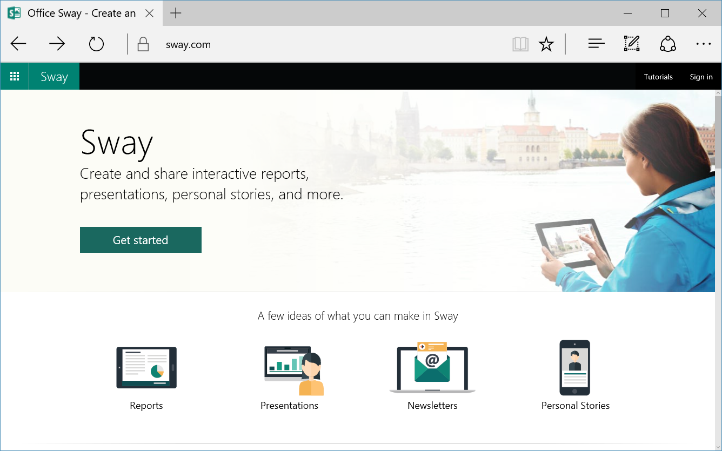

**STEP 2 Sign into MS Sway**

Login to Sway or create a new Sway account.

**STEP 3 Create a New Sway**

Click [ Create New ] on the menu bar of the application.

If you prefer you could instead click [ Start from a topic ] or   
 [ Start from a document ] to commence your storytelling.

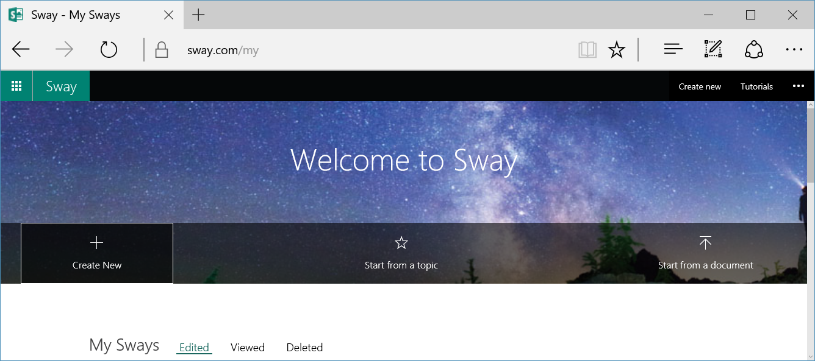

**PROJECT Using MS Sway to Design a Graphics Presentation**

**Step 4** **Title Your Sway**

Choose an appropriate name for your Title Card.

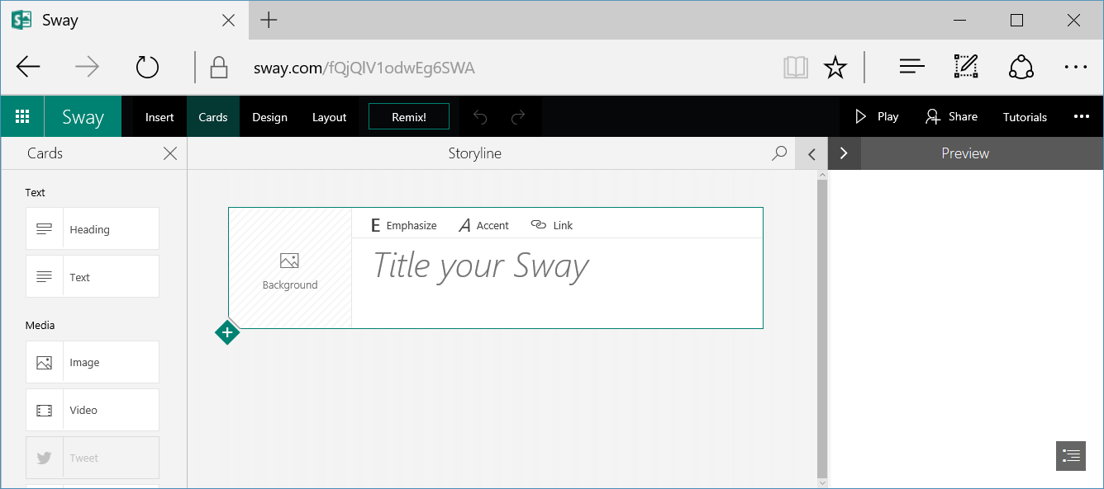

**Step 5** **Select a Background for Your Sway**

After you title your Sway, click the [ Background ] section of the Title card, observe the available suggested background images and drag one of them to the same [ Background ] image section.

Of course, use royalty - free images in your presentation.

**Step 6** **Continue Designing Your Sway Presentation**

Tap the green [ Insert Content ] diamond link to add a section heading to your Sway presentation.



Choose a suitable heading for the first section of your presentation.

**Step 7**  **Continue Designing Your Sway Presentation**

Add additional cards to your Sway. Refer to the specifications of this project, that are listed on the first page, for related content to enhance your presentation.

Image and video media always are welcomed in a presentation to supplement it with visual and dynamic content.

**PROJECT Using MS Sway to Design a Graphics Presentation**

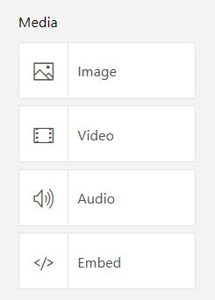

**Step 8**  **Make Use of the Sway Menu**

As you design your presentation, you can use the various links on the Sway main menu to assist in your content layout.



**Step 9**  **Preview Your Sway**

Click [ Preview ] to view the appearance of your presentation. Review your Sway to see if it is professionally designed and conveys the intended message.

**Step 10 Submit Your Sway Link**

Submit the viewable link to your Sway for credit. You can go to [this](https://docs.google.com/spreadsheets/d/118GmYiXxyif5k0qPA_Pdk3lLg78RxXkV8BbxddTnRSc/edit?usp=sharing) Google Sheets link and add in your name in one column and “shared” link of your presentation in another column.

**Step 11 Questions and Answers Concerning this Sway Project**

Open MS Word and, within a new document, place your responses to these questions. Submit your completed MS Word document for credit.

**(1) ( Sway versus PowerPoint )**

Compare Sway with a PowerPoint application. How are they similar? How do they differ?

**(2) ( Features of Sway )**

Does Sway have a built - in Help menu where you can learn about features of the application? If not, what isused within Sway to assist the user to create storytelling presentations?

Refer to the link below for further information.

[**https://support.office.com/en-us/sway**](https://support.office.com/en-us/sway)

**PROJECT Using MS Sway to Design a Graphics Presentation**

**(3) ( Getting Started with Sway )**

[**https://support.office.com/en-us/**](https://support.office.com/en-us/)

Visit the above Web link andsearch for this topic:

Getting Started with Sway

Comment on some interesting facts that you learned while reading the articles comprising the above topic.

**(4) ( Remix! Button )**

What is the purpose / function of the [ Remix! ] Button?

**(5) ( Fun With Sway )**

Now that you have used Sway, what plans do you have for using this application in the future?

----

Other refs.

[ Online Screen recorder ]

<https://screen-recorder.com/>

[ MS Sway 365 ]

https://sway.office.com/my

[ Collaborate with Sway ]

https://www.youtube.com/watch?v=zfBTecFGokI

[ Pro Tips for Sway ]

https://www.youtube.com/watch?v=DsXXostVZY8

[ The Sway Way - Microsoft Sway Tutorials ]

https://www.youtube.com/watch?v=2CwjBK2ENdk

[ How to Build a Presentation in Sway - Part 2 - Microsoft Sway Tutorials ]

https://www.youtube.com/watch?v=Np5Gc_7pb5I

[ Add video and audio files into Sway ]

https://support.microsoft.com/en-us/office/add-video-and-audio-files-into-sway-d2f14842-e103-49c0-9da2-0fbcfcad381f